February 2020

Sunday | Monday | Tuesday | Wednesday | Thursday | Friday | Saturday
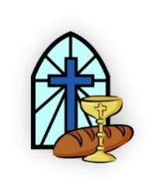 |  |  |  |  |  | 1  Missions Conference
2  Missions Conference  Refuge Youth  Souper Sunday  Fundraiser  Refuge Youth  Super Bowl Game Night  @ Gongloffs | 3 | 4  Backpack Packing Night 6:00 PM  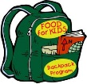 | 5  Wednesday Evening  Prayer Meeting & Kids Club  6:30 PM | 6 | 7 | 8  NAC Men’s  Bible Study  8:00 AM
9 | 11 | 11  Backpack Packing Night 6:00 PM  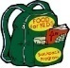  Ladies Book Club 6:30 PM | 12  Wednesday Evening  Prayer Meeting & Kids Club  6:30 PM | 13  Debbie Smith | 14 | 15
16 | 17  Presidents’ Day | 18  Board Meeting  6:00 PM  Backpack Packing Night 6:00 PM  Cut & Knot  6:30 PM | 19  Wednesday Evening  Prayer Meeting & Kids Club  6:30 PM | 20 | 21  Amy Gardner | 22  NAC Men’s  Bible Study  8:00 AM  Kaitlyn Hallberg  Dale Miller  Nolan Smith
23  Small Group Bible Study | 24 | 25  Backpack Packing Night 6:00 PM  Ladies Book Club 6:30 PM  Jeannie Ross | 26  Wednesday Evening  Prayer Meeting & Kids Club  6:30 PM  Helen Kush | 27  Maria Pajak | 28  Michael Abdul-Malak  Budd Bishop  Betty Darby | 29

