February 2021

Sunday | Monday | Tuesday | Wednesday | Thursday | Friday | Saturday
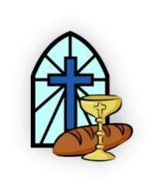 | 1 | 2  Cut & Knot  Blanket Ministry  6:30 PM | 3  Wednesday Evening  Prayer Meeting & Kids Club  6:30 PM | 4 | 5 | 6  NAC Men’s  Bible Study  8:00 AM  CPR/AED Class  11:00 AM
7  Communion  Louis Kavulla | 8 | 9  Ladies Book Club 6:30 PM | 10  Wednesday Evening  Prayer Meeting & Kids Club  6:30 PM | 11 | 12 | 13
14 | 15  President’s Day | 16  Board Meeting  6:00 PM  Cut & Knot  Blanket Ministry  6:30 PM | 17  Wednesday Evening  Prayer Meeting & Kids Club  6:30 PM | 18 | 19 | 20  NAC Men’s  Bible Study  8:00 AM
21 | 22  Kaitlyn Hallberg  Dale Miller  Nolan Smith | 23  Ladies Book Club 6:30 PM | 24  Wednesday Evening  Prayer Meeting & Kids Club  6:30 PM | 25  Jeannie Ross | 26  Helen Kush | 27  Maria Pajak
28  Membership Class  Michael Abdul-Malak  Budd Bishop  Betty Darby | Mar 1st | 2nd | 3rd  Wednesday Evening  Prayer Meeting & Kids Club  6:30 PM | 4th  Lauren Bobby  Hannah Kent | 5th | 6th  NAC Men’s  Bible Study  8:00 AM  Cody Swartz

