
May 2022
Sunday | Monday | Tuesday | Wednesday | Thursday | Friday | Saturday
1  Monica Gongloff | 2 | 3  Cut & Knot Prayer Blanket Ministry  6:30 PM | 4  Bible Study,  Kids On a Mission  @ NAC 6:30 PM  Refuge Youth  @ The Trimble’s  6:30 PM | 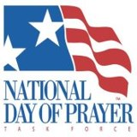  5 | 6 | 7  Ida Hoffer
8  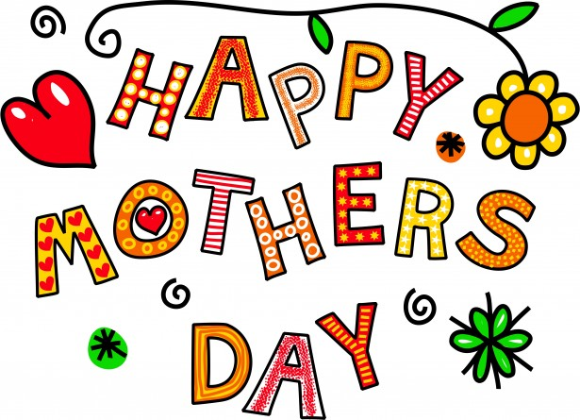  Lori Carnahan | 9 | 10  Ladies Book Club 6:30 PM   | 11  Bible Study,  Kids On a Mission  @ NAC 6:30 PM  Refuge Youth  @ The Trimble’s  6:30 PM | 12  Josh Gongloff | 13  Susan Morgenstern | 14  NAC Men’s Bible Study 8:00 AM
15 | 16  Connie Kahle | 17  Board Meeting  6:00 PM  Cut & Knot Prayer Blanket Ministry  6:30 PM | 18  Bible Study,  Kids On a Mission  @ NAC 6:30 PM  Refuge Youth  @ The Trimble’s  6:30 PM | 19 | 20 | 21  Church Workday  9:00 AM - Noon
22  VBS Meeting following the service.  Chris Bobby  Tom & Marge Toth | 23 | 24  Ladies Book Club 6:30 PM  Holly Bobby | 25  Bible Study,  Kids On a Mission  @ NAC 6:30 PM  Refuge Youth  @ The Trimble’s  6:30 PM | 26 | 27 | 28  NAC Men’s Bible Study 8:00 AM
29 | 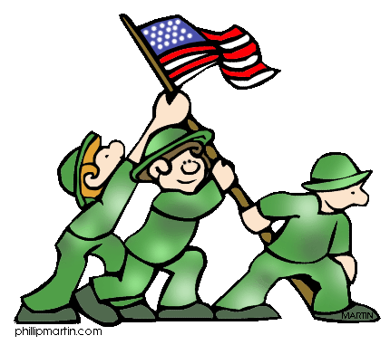  30  Memorial Day | 31 | June 1st  Bible Study,  Kids On a Mission  @ NAC 6:30 PM  Refuge Youth  @ The Trimble’s  6:30 PM | 2nd | 3rd  Laura Clevenger | 4th  Dick & Marilyn Scott

